Tandy 1000 EX/HX
3-in-1 Upgrade
Version 2
Owner’s Guide

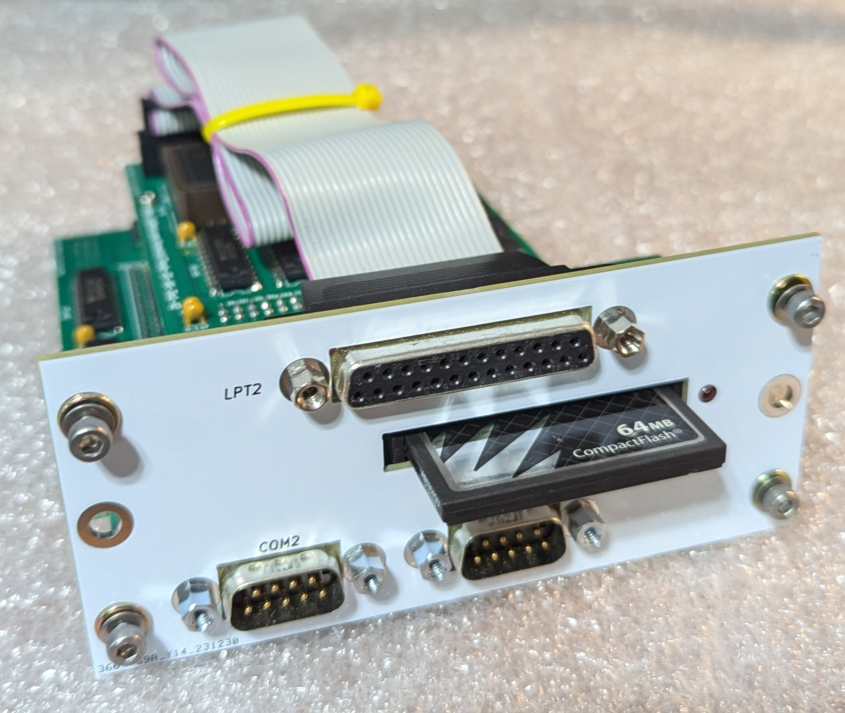

Last Revised January 2025
CONTENTS
INTRODUCTION 4
Description 4
Memory 4
I/O Ports 5
XT-IDE 5
Compatibility 6
INSTALLATION 7
Contents 7
Configuration 7
Installing the 3-in-1 V2 Upgrade 8
OPERATION 11
Memory 11
I/O Ports 11
XT-IDE 12
XT-IDE Serial Drives 13
COMPONENT LIST 14
WARRANTY 15

ABOUT THIS GUIDE
The information found in this guide has been compiled with the utmost attention to detail. However, this does not guarantee complete accuracy. This guide is provided ‘As Is’ and may contain technical inaccuracies or typographical errors. Any references in this document to other companies, products, or services are provided for convenience only and do not in any way serve as an endorsement or recommendation. Companies, products, or services identified throughout this document may be trademarks or service marks of others. All rights reserved.

This product is derived from the ‘Tandy-EX-HX-3in1-V2’ project created by Rob Krenicki. Rob’s original GitHub repository can be found here: https://github.com/rkrenicki/Tandy-EX-HX-3in1-V2

Rob’s Tindie shop can be found here: https://www.tindie.com/stores/rkrenicki/

Details on this project, including up-to-date versions of this document, can be found here: https://github.com/leadacid44/Tandy-EX-HX-3-in-1-V2








INTRODUCTION
Thank you for purchasing the Tandy 1000 EX / HX 3-in-1 V2 Upgrade!

Description
The Tandy 1000 EX and HX systems originally came with just 256Kb of system memory, no serial ports, no hard drive, and a non-standard expansion slot. These limitations have made the EX / HX somewhat unattractive for the modern vintage computer enthusiast. While there were contemporary ways to expand the system’s capabilities, today these upgrades are uncommon and difficult to obtain. The Tandy 1000 EX / HX 3-in-1 V2 Upgrade is a modern solution that overcomes these original limitations by providing the following features:
- Fully expanded system memory - 640Kb conventional + 96Kb UMB
- Two Standard DE-9 RS232 Serial Ports
- Standard DB-25 Parallel Port
- XT-IDE ‘CF Lite’ Interface
Compared to the original 3-in-1 Upgrade, version 2 provides two serial ports and a second parallel port, otherwise the upgrades are identical.

Memory
The 3-in-1 V2 Upgrade uses a 4Mbit static random access memory (SRAM) chip to provide an additional 512 kilobytes of system memory. In combination with the original 256Kb of system memory, your computer will now have a total of 768Kb of system memory configured as 640Kb of conventional memory, plus an additional 96Kb of UMB (Upper Memory Block) memory.

Historically, memory upgrades for the Tandy 1000 EX / HX (such as Tandy’s ‘Memory PLUS Expansion Adapter’ P/N 25-1062) provided an additional Direct Memory Access (DMA) controller to handle (among other things) the refresh timing for the adapter’s added DRAM memory. As the 3-in-1 V2 Upgrade uses SRAM, which does not have such refresh requirements, the DMA functionality is not needed. The presence or lack of DMA does not impact performance for most aspects of the system.

I/O Ports
The 3-in-1 V2 Upgrade uses the Texas Instruments TL16C552 communications chip to provide two standard 16550-based serial RS-232 ports, as well as one enhanced bi-directional parallel printer port. The serial ports are configured as ‘COM1’ and ‘COM2’ and are capable of communications of up to 115kbit/s. The parallel port is configured as ‘LPT2’ and supports bidirectional communications. The serial ports are perfect for connecting a serial mouse or communications with other systems, and the parallel port is perfect for connecting a printer, ZIP drive, Xircom Ethernet adapter, or other such parallel device.

XT-IDE
The 3-in-1 V2 Upgrade implements a “XT-CF-lite rev.2” style XT-IDE adapter, which provides the standard XT-IDE Universal BIOS (XUB) and a CompactFlash socket that is accessible from the rear of your computer.

wThe most obvious function of XT-IDE is that it makes it possible to use a CompactFlash (CF) card as a solid-state hard disk. A bootable, pre-formatted CF card has been included with your 3-in-1 Upgrade. The CF card has a minimal version of FreeDOS 1.3, and has been tested and verified as working with your adapter. A series of helpful utilities and example configurations for your Tandy EX / HX are also included. This card will help you verify that the 3-in-1 adapter is functional, as well as aid in the process of installing the operating system of your choice.

Another extremely useful function of XT-IDE is that it is able to emulate a floppy drive over a serial connection. This allows for booting of floppy images without the need for physical disks, and bypasses size limitations of the internal hardware. Normally the Tandy 1000 EX / HX are limited to just 360k 5.25” or 720k 3.5” floppy disks, but with the XT-IDE software, it is possible to read, write, and boot 1.44MB floppy disk images.

Compatibility
The 3-in-1 V2 Upgrade is only compatible with the Tandy 1000 EX or Tandy 1000 HX. The upgrade is not compatible with any other PLUS slot expansion adapters and must be the only adapter installed - all other adapters must be removed. Physically, the upgrade will take all three slots on the rear of your computer.

The Tandy 1000 EX / HX comes standard with a parallel port, but uses a card-edge style connector that was standard for Tandy at the time. The upgrade provides a second parallel port (LPT2) using the more common DB-25 connector. The upgrade does not interfere with operation of the first parallel port.

The upgrade’s CompactFlash interface is generally compatible with all CompactFlash cards, however as there are a wide variety of cards available, not all cards may work the same, or at all. It is generally not recommended to use MicroSD-to-CF card adapters, nor MicroDrive style cards. XTIDE has a size limit of 8.4GB, but there are also size limits based on your chosen OS. For example, MS DOS 3.3 and older are limited to 32MB partitions, whereas 4.0 and higher can support 2GB partitions. A 64 MB card is included with the adapter, which is generally enough for most things to do on an XT class machine. For more details on compatible cards, consult the XT-IDE project documentation.

The upgrade is compatible with both the original Tandy 1000 EX / HX Intel 8088 CPU, as well as the common NEC V20 CPU upgrade. The upgrade ships with the standard XT-IDE R602 BIOS which is compatible with both processors, but an optional enhanced BIOS is available specifically for the NEC V20, which can improve disk performance. Contact your dealer for more information.

INSTALLATION
Your 3-in-1 V2 Upgrade was tested and inspected prior to shipping, and was found to be free of mechanical and electrical defects. Please take a moment to inspect the product for any damage that may have occurred in transit. Save all packing materials until installation is complete. If damage is found, contact your dealer before proceeding.

Contents
Your Tandy 1000 EX-HX 3-in-1 V2 Upgrade package will contain:
- Tandy 1000 EX-HX 3-in-1 V2 Upgrade board
- 64MB CompactFlash card
- 4x M3 retention screws + washers
- This documentation
If you do not have each of these items, contact your dealer before proceeding.

You will need to provide:
- 2.5mm hex (Allen) screwdriver
- #2 Phillips screwdriver

Configuration
The 3-in-1 V2 Upgrade board requires no additional configuration for normal operation, and is ‘plug and play’. There is one jumper, ‘J1’, located under the I/O mezzanine board which controls whether the XT-IDE EEPROM is in ‘Write Enable’ mode. The default is for the jumper to be open (removed) to disable writes. Unless you plan to write to the EEPROM, such as for on-system XT-IDE updates, it is strongly recommended that this jumper be left open. If you wish to change the jumper setting, you must remove the mezzanine board, set the jumper, and then replace the mezzanine board.
Jumper | EEPROM  Write Enable | EEPROM  Write Disable
JP1 | CLOSE | OPEN *

Installing the 3-in-1 V2 Upgrade

Warning: Internal components of the computer, as well as the 3-in-1 V2 Upgrade board itself, are sensitive to static discharge. Follow the usual static discharge handling rules: don’t perform work in carpeted areas, don’t excessively handle components, limit your moments around the room, ground yourself by touching an earthed metal object before work, etc.

Caution: Shock hazards may exist within the computer. Do not open the cover unless you have unplugged the computer from all electrical sources.

- Turn off power to the computer and all peripherals (display, printer, etc.)
- Disconnect all peripherals from the computer and disconnect the computer from all electrical sources.
- Using the 2.5mm hex screwdriver, remove the four included M3 socket head screws and washers from the upgrade board and set aside for later.
- If installed, remove the included CompactFlash card and set aside for later.
- Orient the computer such that the rear is facing you. Remove the plastic option cover located on the top panel by gently pressing down on the edge nearest the front of the computer to disengage the hook-latch, and then slide the cover toward you.
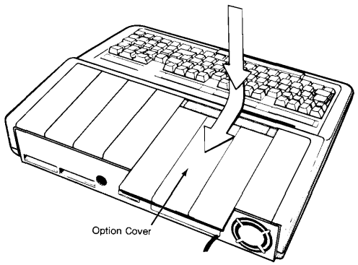Figure 1: Remove Option Cover
- If installed, remove any previously installed PLUS option boards from the computer. The upgrade cannot be installed with other option boards.
- Remove all option slot covers on the rear panel of the computer by removing the #2 Phillips screws.
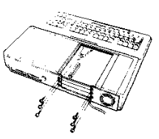Figure 2: Remove covers
- Ensure that the pin header on the computer’s main logic board is clean and free of dust or debris. Clean the pin header if necessary using compressed air.
- Carefully align and lower the upgrade board pin socket onto the pin header on computer’s main logic board. Press gently only on the area surrounding the pin socket to prevent excessive flexing of the board. The faceplate of the upgrade will be flush with the inside rear of the computer. Align the screw holes.

Note! When the upgrade board is seated, check that all pins are fully inserted into the socket and that the board is parallel to the main logic board. Do not use excessive force. The shroud on the main logic board pin header will help align the pin connectors. It may be necessary to gently lift the upgrade board slightly to align the mounting screw holes of the faceplate with the rear of the computer.

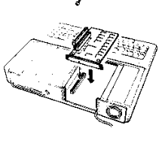Figure 3: Insert upgrade board
- Reinstall the M3 socket head screws and washers into the upgrade board snugly. Do not over-tighten.
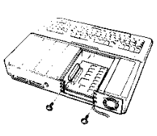Figure 4: Reinstall screws
- Replace the option cover by sliding it forward until it snaps into place.
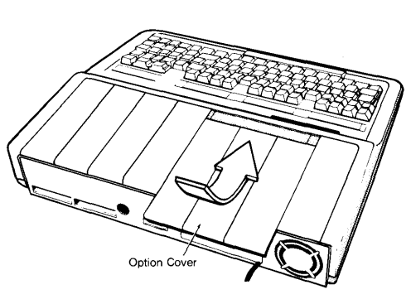Figure 5: Replace Option Cover
- Reinsert the CompactFlash card. The front face of the card should be orientated up.
- Installation is complete.

OPERATION
Operation of the 3-in-1 V2 Upgrade board is almost entirely automatic. No specific configuration of the board is necessary for normal functionality, however a few quality-of-life changes can be made to improve operation of your computer with the upgrade.

Memory
The 3-in-1 V2 Upgrade will automatically increase the computer's conventional memory to 640Kb. On power up, the computer will display “Memory Size = 640k” on the screen, indicating that the upgrade is properly connected and functional. No other action is required to use this additional memory.

Note! If the computer does not display 640k of system memory at system power on, or there appears to be other problems with the upgrade, immediately power off the computer and confirm that the upgrade board is properly seated. If you continue to have problems, consult your dealer.

An additional 96Kb of UMB (Upper Memory Block) memory is provided by the upgrade, but most versions of DOS are unable to take advantage of this memory directly. The included Compact Flash card has example configurations for using the ‘DOSMAX’ utility to move MS-DOS into this UMB, freeing up additional conventional system memory. Typical MS-DOS 5 configurations using DOSMAX can yeild 624Kb of conventional memory available for user programs. Should you wish to use this utility, examine the example configurations and implement as necessary for your situation.

I/O Ports
The I/O ports of the 3-in-1 V2 Upgrade follow industry standard settings:
- Serial Port 1: COM1, I/O 0x3F8, IRQ 4
- Serial Port 2: COM2, I/O 0x2F8, IRQ 3
- Parallel Port 2: LPT2, I/O 0x278, IRQ 2
Your computer will automatically detect the new devices. The port addresses and IRQ configurations are hard-wired and cannot be changed. System information programs like Norton System Info will indicate if the system has correctly detected the ports.

XT-IDE
The 3-in-1 V2 Upgrade provides a “XT-CF-lite rev.2” style XT-IDE adapter, providing the standard XT-IDE Universal BIOS and a Compact Flash socket that is accessible from the rear of your computer. The XT-IDE ROM is mapped to the 0xC000 address, and the CF socket to the 0x300 address. Version ‘R602’ of the XT-IDE software is programmed into the EEPROM. Operation of the XT-IDE software and interface is the same as any standard XT-IDE implementation, so it is recommended to reference the official XT-IDE documentation for specific operational instructions.

When installed in a Tandy 1000 EX, the XT-IDE software will start automatically. When installed in a Tandy 1000 HX, the XT-IDE software will not necessarily start automatically, but instead follow the existing configured boot order. By default, the HX will boot the built-in system ROM containing Tandy MS-DOS v2.11, and then either load the command prompt, load a menu, or load Tandy Personal DeskMate. The Tandy ‘SETUPHX.COM’ program can change this behavior, and a copy is included on the provided Compact Flash card for your convenience. If your system boots to the menu, press the F4 key for ‘Startup from Internal Drive’ and the XT-IDE software will load. If you want the XT-IDE software to load every time, run the setup program and change the ‘PRIMARY START-UP DEVICE’ setting to ‘DISK’.

The 3-in-1 V2 Upgrade board has a single jumper ‘JP1’ which enables writes to the EEPROM for future XT-IDE software upgrades. The jumper should be left removed for normal operation.

XT-IDE Serial Drives
An extremely useful function of XT-IDE is its ability to emulate a floppy drive over a null-modem serial connection to a host PC. Operation of the XT-IDE serial drive feature is the same as any standard XT-IDE implementation, however there are a few tips specific to the Tandy 1000 EX / HX and the 3-in-1 Upgrade:
- It has been found that version “2.0.0 Beta 3 (Apr 16 2019)” of ‘serdrive.exe’ is the most compatible with the Tandy 1000 EX / HX 3-in-1 Upgrade. A copy of this version is available on the GitHub repository.
- XT-IDE is able to use most common disk image sizes, as well as custom sizes. The Tandy 1000 EX / HX is able to read 360Kb, 720Kb, 1.2Mb, and 1.44Mb images, but is still limited by operating system compatibility. For example, the built-in system ROM containing Tandy MS-DOS v2.11 does not support 1.44MB disks.
- Booting from an emulated disk requires two keystrokes on the XT-IDE splash screen; first press ‘F6’ to perform the ComDetect, then press ‘B’ to boot from the emulated disk. The internal disk drive letter ‘A’ will be swapped with the emulated disk drive letter ‘B’.
- The maximum stable serial transfer speed is 115.2Kbps.
- Occasionally, the ‘serdrive.exe’ program seemingly does not properly initialize the serial port on the host PC. Generally this can be seen as the XT-IDE not detecting the emulated disk. It has been found that running a serial terminal program like ‘TeraTerm’ or ‘PuTTY’ on the host PC, opening a connection to the COM port, and then closing that program, will properly ‘set up’ the COM port. Once done, then the ‘serdrive.exe’ program will work as expected.

COMPONENT LIST

Description | Qty | Location | Mouser PN
Main PCB | 1 | N/A | N/A
PCB Back Plate | 1 | N/A | N/A
PCB Mezzanine | 1 | N/A | N/A
2x31 2.54mm Header Socket | 1 | BUS1 | 200-CES13101SD
2x20 2.54mm Header Socket, 11mm height. | 1 | CF-J1 | 517-8540-4500PL
10k Resistor | 3 | R1-R3 | 603-CFR25SJT-26-10K
0.1uF Ceramic Capacitor | 12 | C1-C12 | 594-K104M15X7RF53L2
100uF 16V Electrolytic Capacitor | 1 | CP1 | 647-RNU1C101MDS1
1.8432Mhz 1/2-size Oscillator | 1 | IO-OSC1 | 774-MXO45HS-3C-1.8
DE9 Male Right Angle Connector | 2 | IO-COM1,IO-COM2 | 806-K22X-E9P-N-99
Jackscrew for DE9 connector | 4 | IO-COMxScrew | 636-SFSO4401NR
16C552 Dual UART in PLCC-68 Package | 1 | IO-U1 | 595-TL16C552FNR
PLCC-68 Through Hole Socket | 1 | IO-U1Socket | 575-682444
GD75232N RS232 Driver | 2 | IO-U2,IO-U3 | 595-GD75232N
74LS138 3-to-8 Line Demux | 1 | IO-U9 | 595-SN74LS138N
74LS08 Quad AND Gate | 1 | IO-U10 | 595-SN74LS08N
74LS04 Hex Inverter | 1 | IO-U11 | 595-SN74LS04N
1x2 2.54mm Header Socket | 1 | CF-J2 | 200-CES10101TD
74LS139 Dual 2-to-4 Demux | 1 | CF-U1 | 595-SN74LS139AN
74F521 8-bit Comparator | 2 | CF-U2,ROM-U4 | 595-SN74F521N
74LS245 Tri-state Bus Transciever | 1 | CF-U3 | 595-SN74LS245N
AS6C4008-55PCN 4mbit (512k x 8) Static RAM | 1 | RAM-U6 | 913-AS6C4008-55PCN
74LS00 Quad NAND Gate | 1 | RAM-U8 | 595-SN74LS00N
74LS32 Quad OR Gate | 1 | RAM-U7 | 595-SN74LS32N
39SF010 128k x 8 NOR Flash | 1 | ROM-U5 | 804-39SF010A7CPHE
32-pin Wide DIP Socket | 1 | ROM-U5Socket | 517-4832-6000-CP
CF to IDE Adapter from eBay or AliExpress | 1 | CF-IDEAdapter | N/A
Mounting Tab for Backplate | 1 | J1 | 534-7327
2x11 Pin Female Header | 1 | MEZ IO-J1 | 571-1-829264-1
2x10 Pin Female Header | 1 | MEZ IO-J2 | 571-5-534998-5
2x11 Pin Male Header | 1 | IO-J2
2x10 Pin Male Header | 1 | IO-J3 | 571-5-146256-5
Mezzanine Mounting Hardware | 2 | H1, H2 | N/A
2x13 Pin Male Header | 1 | MEZ IO-J3 | 571-1-826632-3
DB25 Female IDC26 Parallel Port Bracket | 1 | N/A | N/A
64MB CF Card | 1 | N/A | N/A
M3 Rivet nut | 4 | N/A | N/A
M3 Screw + Washer | 4 | N/A | N/A

All 74LSxx series logic ICs can be substituted with any family with "LS" or "T" in the name, such as 74ALSxx, 74ACTxx, 74AHCTxx, or 74HCTxx, etc. This upgrade is designed to use a specific CF to IDE adapter widely available on eBay. It usually has the mark "IDE to CF Ver.D2", fits into an expansion card slot, can can generally be identified by the metal cover over the CF card connector itself. The metal expansion slot plate is removed and a small modification is required to the power connector to make it usable with the 3-in-1 V2 Upgrade.

WARRANTY
No warranty or guarantee of any kind is expressed or implied.

This product is sold WITHOUT ANY WARRANTY; implied or otherwise. No guarantee is provided for MERCHANTABILITY or FITNESS FOR A PARTICULAR PURPOSE. Not liable for damages. Returns are not accepted. Use is entirely at your own discretion and risk. Misuse, accidents, modification, improper handling, etc. are entirely up to you.

Every 3-in-1 Upgrade is manufactured from new parts, or new and serviceable used parts which perform like new parts. Every adapter is tested to be free from defects in materials and workmanship.

Please remember! This is an aftermarket part, made for a 1980’s home computer, by a guy in a shed. If you’re worried that this may damage your computer, perhaps its not for you. If you have any questions, contact your dealer.

Thank you!

Proudly Made in Wisconsin

Either an Alliance AS6C4008 or Samsung K6T4008

